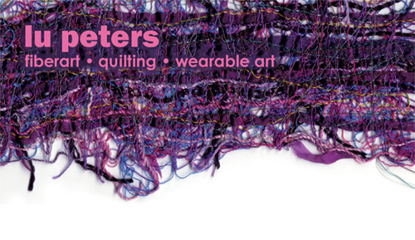
Lingerie Books

Bibliography compiled by
Lu Peters, © 2007-2023
Aspen, Rebecca The Lingerie Handbook; Workman Publishing Co., 2006

Bones, Jan Lingerie Secrets: Sew a Perfect Fit for Everybody, Krause, 2000
The Dress Form, Excellence in Sewing

Her website is located at sewinglingerie.com.

Brighton, Leigh All About Lingerie; 6 Degrees, 2010

Cunningham & Cunningham The History of Underclothes; Dover, 1992

Dominy, Katie Contemporary Lingerie Design; Lawrence King, 2010

Ewing, E. Fashion in Underwear from Babylon to Bikini Briefs; Batsford, 1971

Farameh, Patrice Second Skin: The Erotic Art of Lingerie; Daab Publishing, 2011

Fields, Jill An Intimate Affair: Women, Lingerie, and Sexuality; University of California, 2007

Folli & de Fabianas Lingerie: the Evolution of Seduction; White Star, 2010

Glanville, Jo A Passion for Lingerie; Ryland Peters & Small, 2005

Haggar, Ann Pattern Cutting for Lingerie, Beachwear and Leisure Wear; Blackwell Publishing, LTD., 2004

Hawthorne, R. Knickers; An Intimate Re-Appraisal; Souvenir Press, 2008

Martenson, Kersten Kwik Sew’s Beautiful Lingerie; Kwik Sew, 1990

McGowen-Michael, Joan Knitting Lingerie Style; Stewart, Tabori, and Chang, 2007

Miller, et. al. Lingerie; Alphascript, 2010

Morel, Juliette Lingerie Parisienne; Academy, 1976

Morris, Karen Sewing Lingerie That Fits: Stylish Underwear, Sleepwear, and Loungewear for Everyday Living; Taunton, 2001

Neubauer, Linda Sewing Lingerie; Apple Press, 2007

Quarto Publishing Eds. Lingerie: a Modern Girl’s Guide; Quarto Publishing, 2010

Corsets: a Modern Girl’s Guide; Quarto Publishing, 2010

Seleshanko, Kristina Bound and Determined: A Visual History of Corsets, 1850—1960; Dover, 2011

Shrader, Valerie Van Arsdale Sweet Nothings : Sew Your Own Handmade Camis, Undies and Un-mentionables; Lark, 2009

Singer, Editors Sewing Lingerie/Singer Sewing Reference Library; Creative Publishing International, 1991

Sparks, Linda The Basics of Corset Building; Farthingales

Steele, Valerie Sweet Nothings: Hand Made Camis, Undies and Other Unmentionables; Lark, 2009

The Corset: A Cultural History; Yale, 2003

Waugh, Norah Corsets and Crinolines; TF-ROUTL, 1990 www.amazon.com

Willette & Cunningham The History of Underclothes; Dover

Lingerie websites

thebluegardenia.com/lingerie Supplies
collettepatterns.com Vintage patterns by Saral Mitnick
corsetmaking.com Supplies
elingeria.de European lingerie patterns
dreamweaveryarns.com
farthingales.on.ca Free online class instruction on corset making
patternsthatfityou.com
thesewingplace.com
sewsassy.com/lingerie
sewinglingerie.com Jan Bones (teacher)

